Instructions for Registering to Use AgriBank’s District Connect Site
You will need to follow these instructions the first time you log in. Once registered, you can use the new District Connect URL to navigate directly to the site.
- Navigate to: https://myaccess.microsoft.com/@agribank0.onmicrosoft.com#/access-packages/6447e22b-5661-44c4-b059-4301ed1b553d.
- Sign in with your account (this is your normal Microsoft/SSO login).
- You will see the below screen and should click “Continue.”
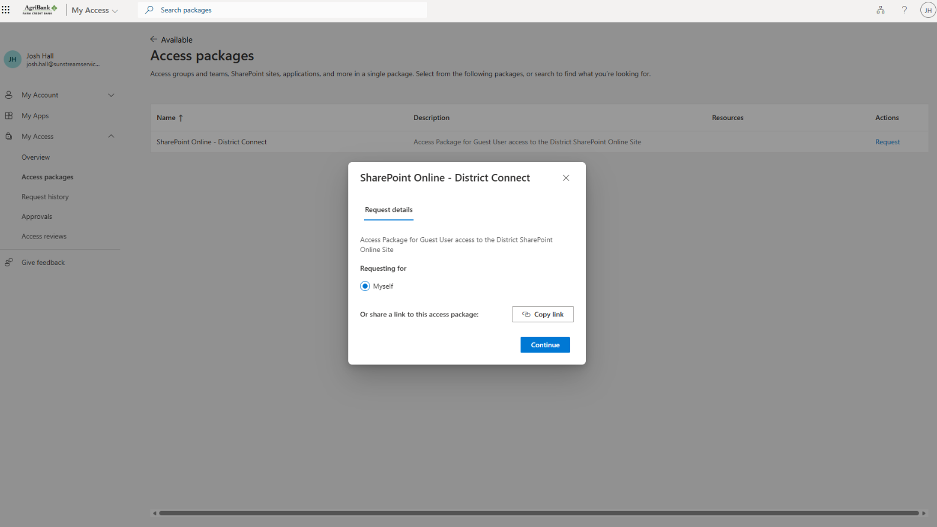
Note: If you receive the below pop-up, you are already part of the site and can navigate directly to Home.
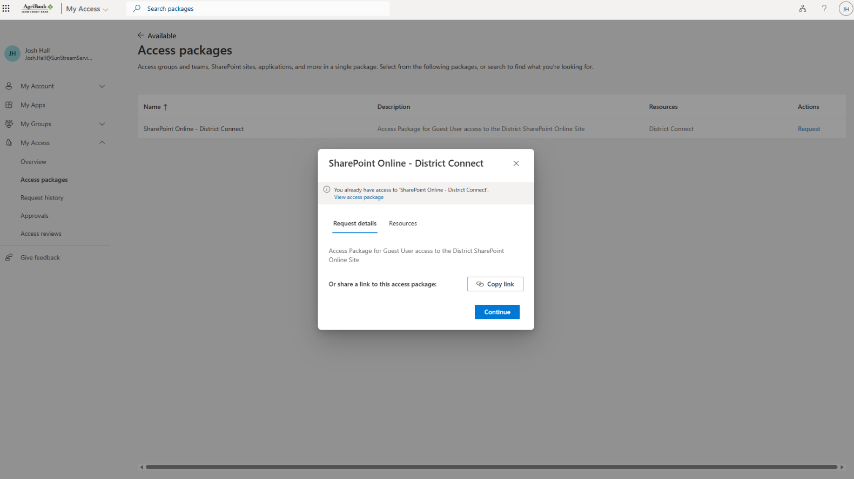

- You do not need to enter a business justification. Click “Submit request.”
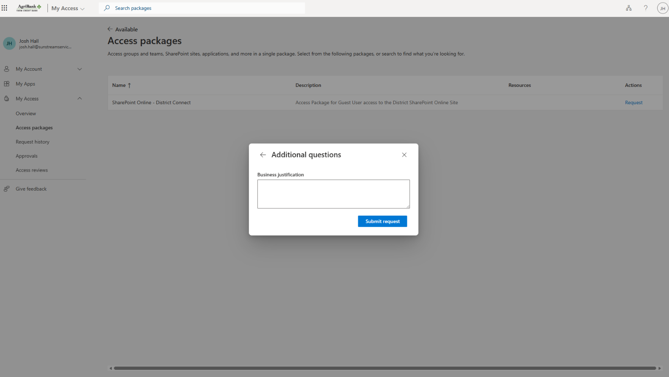
- You will land on this screen and will see a message in the top right that your request is being processed.
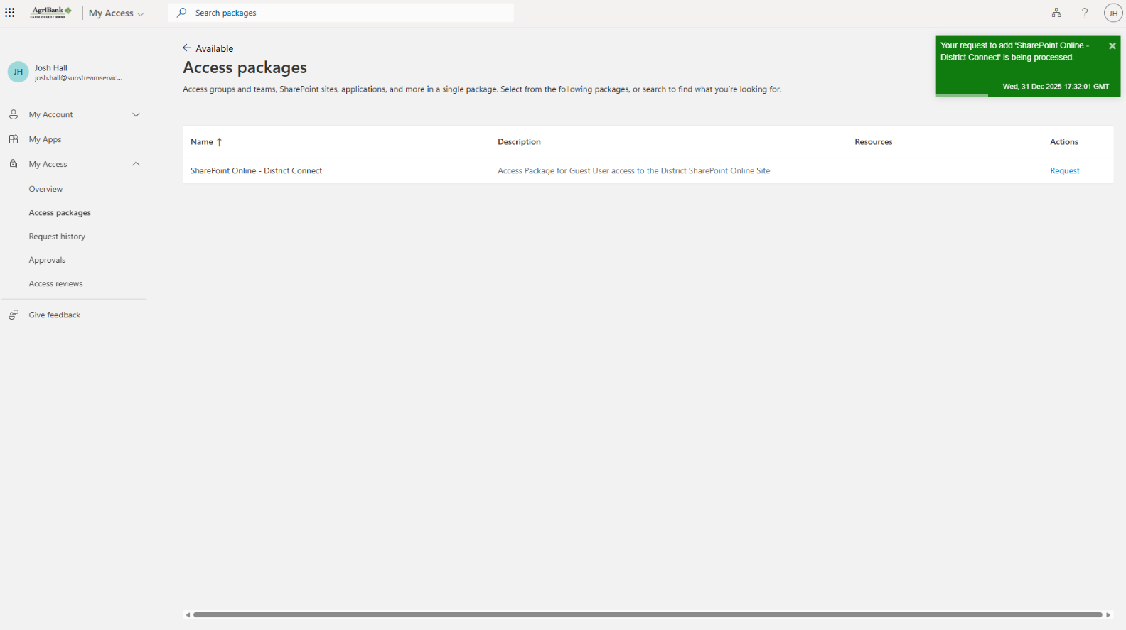
- The system processes the request within seconds, and you may receive an email. This email can be ignored. You can now proceed to District Connect: Home.
